THE HEARING DAY


This guidance is to give you information about what it’s like at a hearing of the Mental Health Tribunal for Scotland.

If your hearing is in the hospital where you are staying, a nurse from the ward will come with you to the hearing room. They are called an escort nurse. They do not take part in the hearing and are just there to support you.

Arriving at the hearing
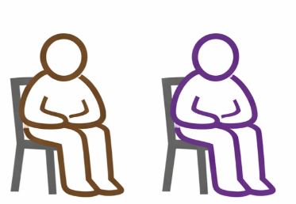

When you arrive at the hearing room you will be met by a person called the clerk. The clerk will show you where to go and give you any other information that might help you before the hearing starts. The clerk will tell the three tribunal members who will be deciding on the case that you have arrived. The three tribunal members will be a convener, who is a lawyer, a medical member who is a doctor, and a general member who has experience of mental health care. The convener will come to meet you before the hearing. If you want to meet the other tribunal members before the hearing, you can.

Before the hearing



The hearing room will have a table, with chairs round it. You can ask to see the hearing room before the hearing starts. You can choose where you want to sit. You can take in a toy or anything else to help you feel comfortable. All hearings are recorded, so you may see a digital recorder on the table. The hearing is private.

Before the hearing starts you can say if you want to go into the room first, or after everyone else. When everyone is in the hearing room, the convener will make sure that each person says who they are and why they are at the hearing. You can say what name you would prefer to use in the hearing (your first name, your second name or something else).

During the hearing


The convener will explain to everyone in the hearing room what is going to happen. You can ask any questions you want about this. The tribunal members will also be writing down notes of what is said, and you can too if you want.

It is important for the tribunal members to know if you have a representative. In some cases, the Tribunal will have decided before the day of the hearing that someone called a curator ad litem should be appointed as your representative. This person will be a lawyer. Their job is to represent your interests at the hearing. They may have come to see you before the hearing, to talk about what you want, what you think and what is likely to happen.

If there isn’t a curator, you can choose someone else to represent you if you wish. Your representative might be a lawyer, an advocacy worker or a friend. Some people have a lawyer and an advocacy worker.


The tribunal members will have read papers that have been sent to them about your case. The hearing is for everyone to have their say about your case and what should happen now. The information that everyone shares at your hearing will help the tribunal members to make their decision about your case.


The tribunal members will want to know what you think about the case, and what you want to happen. Maybe you will tell them yourself, or maybe someone else will speak for you. Even if you have a representative you can still speak to the tribunal yourself if this is what you want to do. You can speak to the members at the beginning of the hearing or at the end of the hearing. Or a bit of both – or not at all.
And you do not have to stay for the whole of the hearing. Your representative or support person can speak on your behalf and you will be told later about any decision made.



Parents or guardians can come to the hearing as well. The members will want to hear from them too.


If you feel you don’t want to speak in front of some people at the hearing, you can say that, or ask your representative to say that for you. The members may be able to arrange for people to speak to them without some other people there at the same time.



The members might feel they need to ask you some questions. They should check with you first that you are willing to answer – you don’t have to answer any questions if you don’t want to.

If the tribunal hearing lasts more than about an hour it is likely that the convener will arrange for a break. If you have a set time for a meal or a snack, the tribunal members will work round that. You can ask for a break at any time in the tribunal hearing if you feel like one. Just say that, or ask the person sitting next to you to say it. And if you decide you don’t want to come back to the tribunal hearing after a break, you don’t have to.

After the hearing
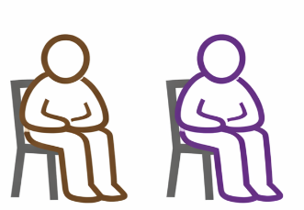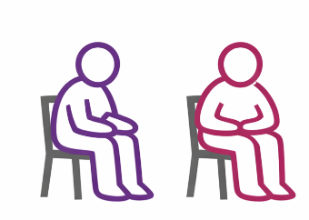

Once the members have heard from everyone, they will tell you how long they think it might take for them to make a decision. Usually, they will ask everyone to leave the room for a time, so they can have a discussion. If they can say what their decision is on the day, they will ask everyone back into the room for that. If they need more time to think about their decision, they will say that everyone can leave, and tell people the decision later. Sometimes they can’t make a final decision, and they will say there needs to be another hearing. That might be about four weeks later.


If the hearing is on the phone, or by video, it will be similar to what is described here. It is likely you will take part from a room where you can be with people who support you, like your parents, your representative and your escort nurse. At some in person hearings, one or two people might be taking part by phoning in.




We hope this information is helpful. If you have questions that haven’t been answered, you can ask your mental health officer (MHO), your responsible medical officer (RMO) or a nurse or advocacy worker on the ward.

